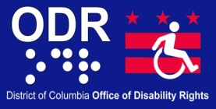
ADA TODAY
Newsletter
Volume 2 Issue 12 November 2012

Office of Disability Rights (ODR) and Developmental Disabilities Council (DDC) Host 2012 Disability Mentoring Days
Sixty-two (62) students from three District of Columbia high schools and 4 DC colleges and universities participated in this year’s annual Disability Mentoring Days (DMD) during the months of October and November. Thirteen private companies and government agencies participated in the event, including 3 Councilmembers and the Deputy Mayor for Health and Human Services. During DMD, the students visited a District job site of their choosing in order to learn more about what the employees at the agency or company do in their day-to-day work life, as well as to learn about potential employment opportunities that could be available for them after graduation. Below are pictures from some of this year’s events:

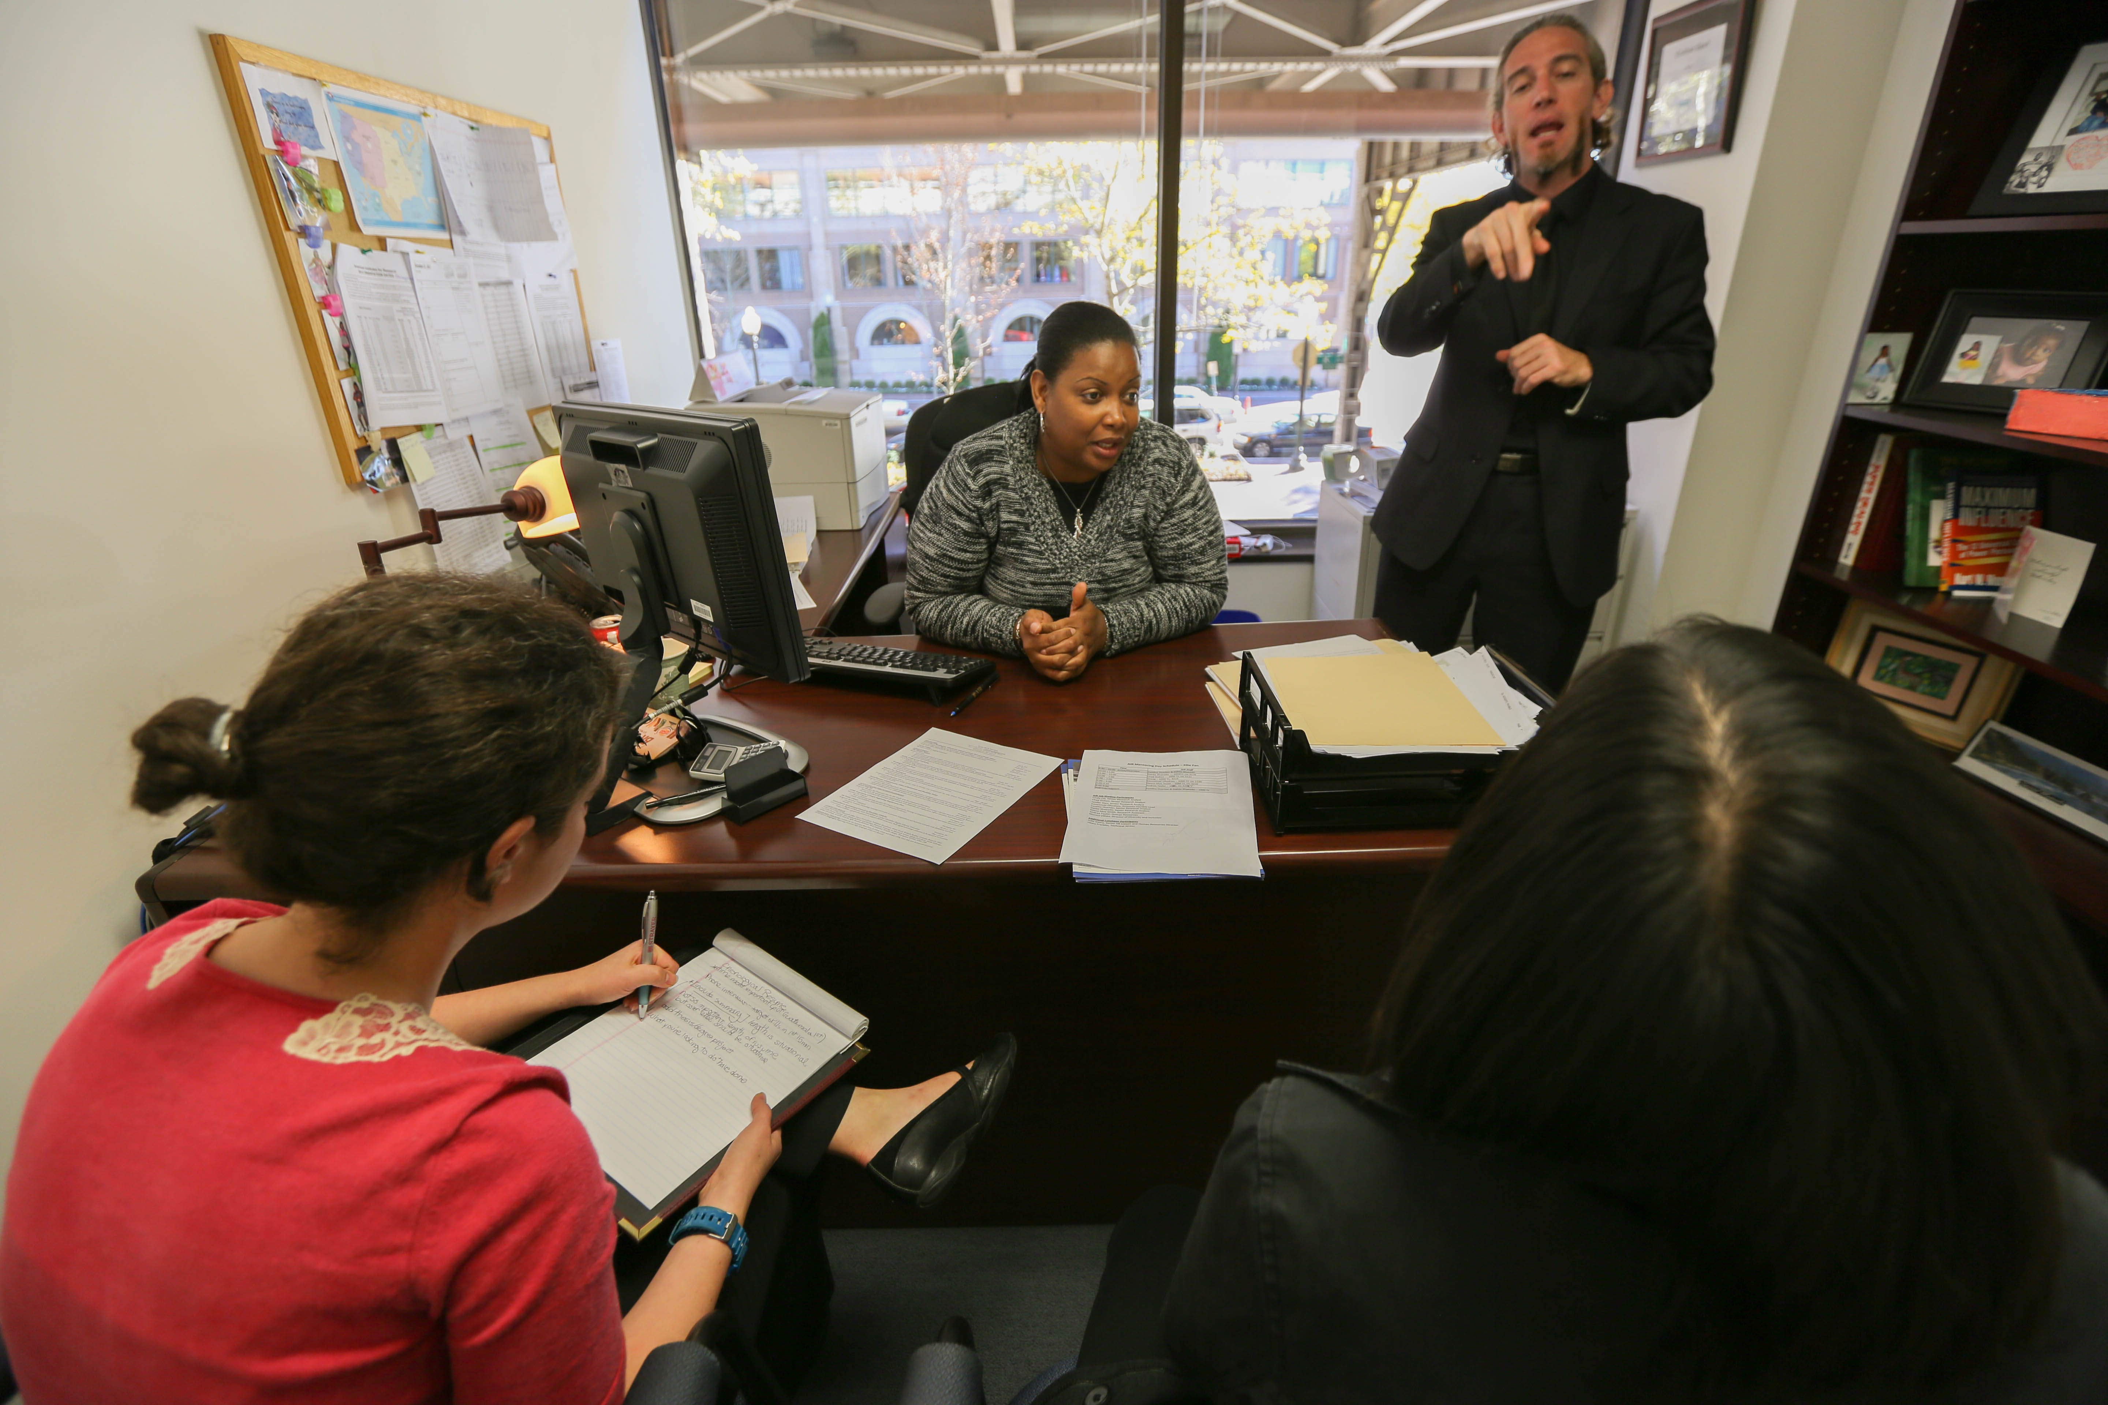
Students learn about available employment opportunities at the American Institutes for Research

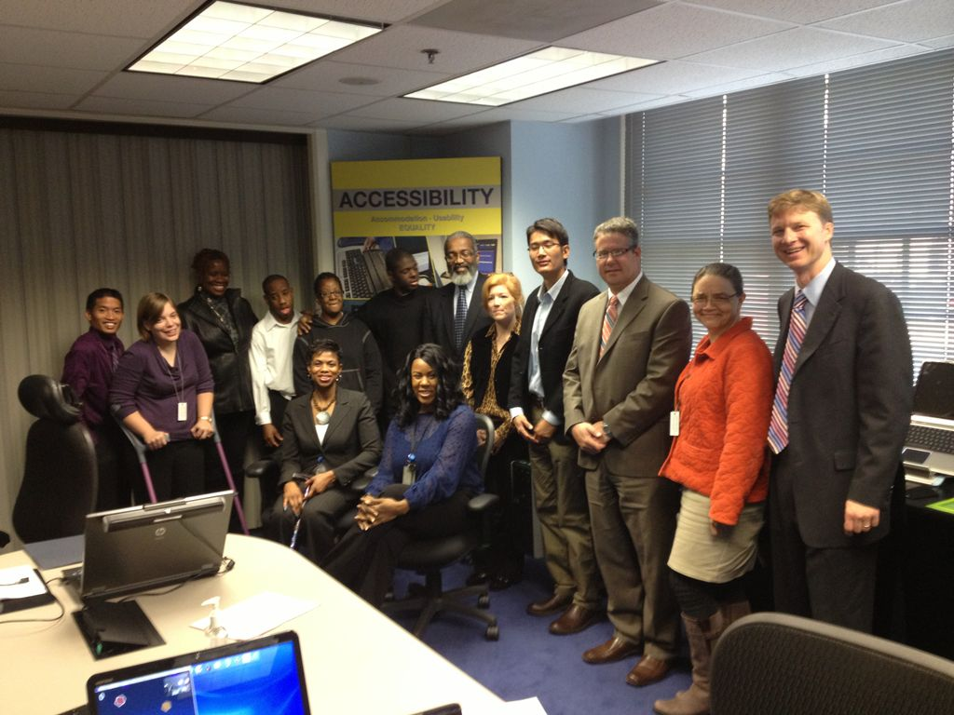

A
A group of high school students pose with ODR and DDC staff during a tour of the assistive technology at the US Department of Agriculture (USDA) Target Center.

Local News & Information

Emergency Preparedness: What's the Plan?
In light of the recent hurricane on the eastern seaboard, more employers may be considering developing emergency preparedness plans and need answers on how to include employees with disabilities. A guide provided by the Job Accommodation Network (JAN) can help businesses that are developing emergency evacuation plans. Accommodation and Compliance Series: Employers’ Guide to Including Employees with Disabilities in Emergency Evacuation Plans addresses the legal requirements for emergency evacuation under the ADA and focuses on identifying people who may need accommodations in an emergency evacuation based on the EEOC guidance, common accommodations, and plan implementation and maintenance.
Click here for additional resources on emergency preparedness and people with disabilities.
For more information and resources, visit www.AskEARN.org.

Federal News & Information

DuPriest and Sons To Pay $24,000 to Silk-Screener Fired Because of Disability
EEOC Lawsuit Alleged DuPriest and Sons Laid Off Worker Due to His Need For Dialysis
DALLAS - DuPriest and Sons Holding and other related entities that owned and operated a Dallas silk-screening company have agreed to pay a long-term former employee $24,000 to settle a disability discrimination lawsuit brought by the U.S. Equal Employment Opportunity Commission (EEOC), the agency announced today. The EEOC had charged that DuPriest violated the Americans with Disabilities Act (ADA) by selecting an employee for layoff because of a recent hospitalization for diabetes and kidney failure.

According to the EEOC's lawsuit, after 38 years on the job, Alfred Garza was informed of his selection for termination soon after he informed the employer that he would be needing dialysis in the near future. A member of management told him that the company could "no longer afford" him. In an atmosphere where another manager in the family-run company used to kick Garza's cane as a "joke," Garza realized that his declining health was being used against him when the choices were made for layoff. For more information: http://www.eeoc.gov/eeoc/newsroom/release/10-19-12.cfm

Intellectually Disabled Workers Awarded $1.3M for Pay Discrimination by Henry's Turkey Service
Further Proceedings on Disability-Based Abuse and Harassment Allegations Lie Ahead
DALLAS -- Hill Country Farms Inc., doing business as Henry's Turkey Service, violated the Americans with Disabilities Ac ‘t (ADA) by paying 32 workers with intellectual disabilities severely substandard wages, a judge has ruled in a lawsuit filed by the U.S. Equal Employment Opportunity Commission (EEOC). The court ordered the company, based in Goldthwaite, Texas, to pay its former employees lawful wages totaling $1.3 million for jobs they performed under contract at a turkey processing plant in West Liberty, Iowa between 2007 and 2009. For more information: http://www.eeoc.gov/eeoc/newsroom/release/9-19-12a.cfm

EEOC Obtains $40,000 in Settlement of ADA Case with Jim Walter Resources
Mine Worker Was Denied Assignment to Area That Would Not Damage His Hearing Aids, Federal Agency Charged
BIRMINGHAM, Ala. - Birmingham-based Jim Walter Resources (JWR), the world's largest producer of Blue Creek coal, will pay $40,000 and furnish other relief to settle a disability discrimination lawsuit filed by the U.S. Equal Employment Opportunity Commission (EEOC), the agency announced today.
According to the EEOC's suit, while working in Jim Walter's Mine No. 5 near Brookwood, Ala., Rocky Davis, who has profound hearing loss, was continuously assigned to areas of the mine that exposed him to working conditions that would harm his hearing aids. In April 2007, Davis requested an accommodation to be assigned to another location; however, JWR failed to honor his request. Instead, the EEOC said, JWR removed Davis from the mine and would not permit him to return until he presented a full medical release. Upon Davis's return to work, JWR sent him back to the area of the mine that it knew could affect his ability to hear. For more information: http://www.eeoc.gov/eeoc/newsroom/release/10-19-12a.cfm

For Information about ODR’s Newsletter call 202-724-5055 or visit the web at odr.dc.gov.

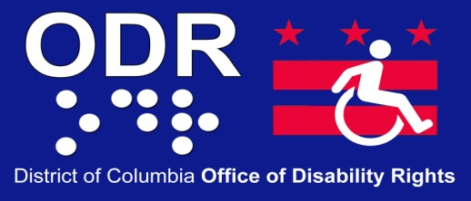

441 4th Street NW
Suite 729 North
Washington DC 20001

Phone: (202) 724 - 5055
Fax: (202) 727 -9484
E-mail:
ODR.Complaints@dc.gov

Visit us on the web: http://odr.dc.gov

MISSION STATEMENT
Visit us on the web: http://odr.dc.gov
The mission of the District Office of Disability Rights (ODR) is to ensure that the programs, services, benefits, activities and facilities operated or funded by the District of Columbia are fully accessible to, and useable by people with disabilities. ODR is committed to inclusion, community-based services, and self-determination for people with disabilities. ODR is responsible for overseeing the implementation of the City's obligations under the Americans with Disabilities Act (ADA) as well as other disability rights laws.

