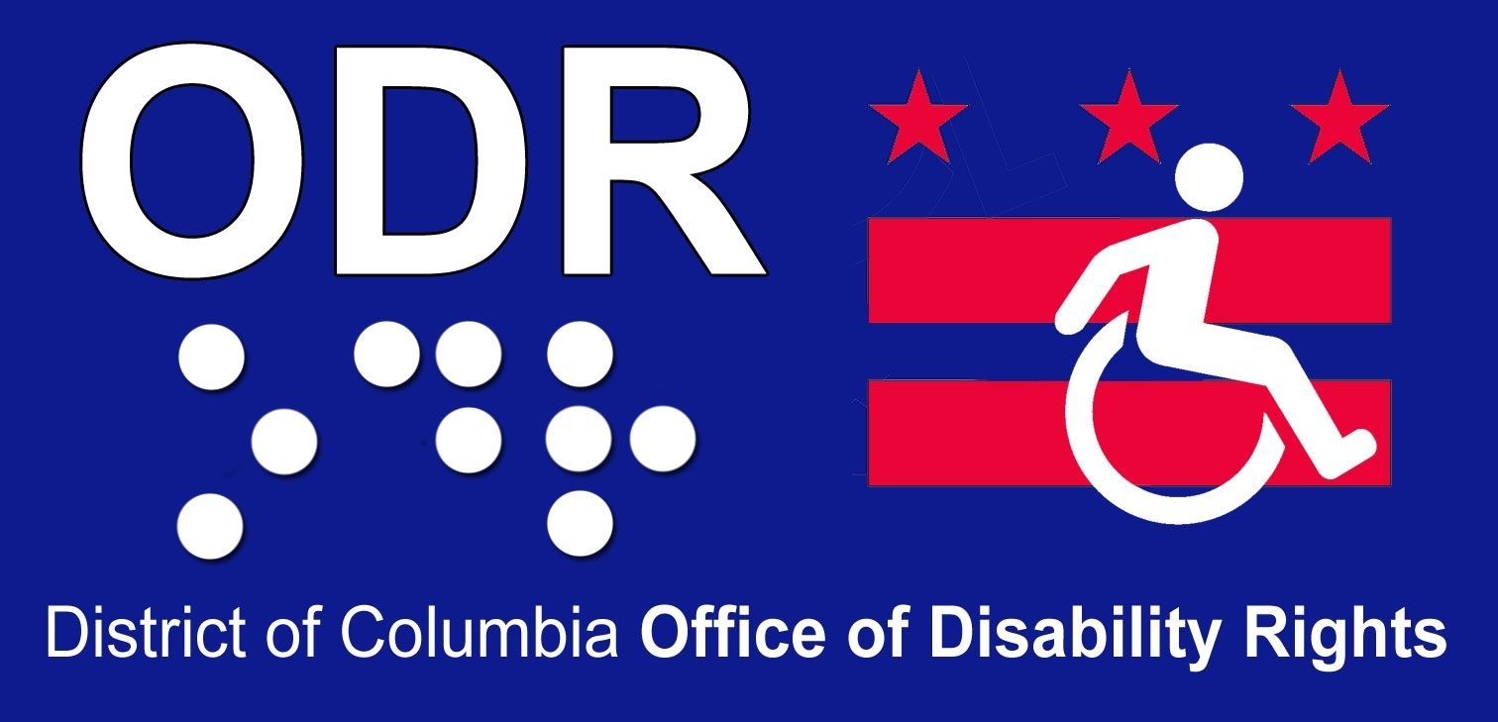
Office of Disability Rights
Testimony of Derek K. Orr, Director

Council of the District of Columbia
Committee on Human Services

Budget Oversight Hearing
April 29, 2013
11:00 am
John A. Wilson Building
Room 412
1350 Pennsylvania Avenue, NW
Washington, DC 20004

Good morning, Councilmember Graham and other distinguished members of the Committee, staff and stakeholders. I am Derek Orr, Director of the District of Columbia Office of Disability Rights. Thank you for the invitation to appear before you today and present highlights of the Office of Disability Rights Fiscal Year 2014 budget.

The mission of the Office of Disability Rights is to ensure that the programs, services, benefits, activities and facilities operated or funded by the District of Columbia are fully accessible to, and useable by, people with disabilities. ODR is responsible for ensuring that District government is in compliance with the Americans with Disabilities Act of 1990 (ADA) and other federal and District disability rights laws. To accomplish this mission, we provide training, technical assistance, policy recommendations, expertise and informal dispute resolution to District agencies and the disability community.

The Mayor’s FY 2014 budget for the Office of Disability Rights is an effective and efficient budget plan that ensures the necessary funding for the programs and services legislatively mandated and new initiatives planned for the Office of Disability Rights.

The proposed Office of Disability Rights budget for Fiscal Year 2014 is $1,842,443. This is an increase of .2 percent over Fiscal Year 2013 approved budget of $1,839,671. The budget is comprised of $980,077 in Local Funds; $775,100 in Federal Grant Funds and $87,266 in Intra-District Funds.

The Local Funds budget supports the Office of Disability Rights and Agency Management Program which is comprised of 8 FTE’s; 5 FTE’s in the Office of Disability Rights and 3 FTE’s in the Agency Management Program.

The Federal Grant dollars fund the mandated initiatives of the DC Developmental Disabilities Council as well as 3 FTE’s; the Executive Director – Mr. Mat McCollough who is participating in today’s hearing – a Program Analyst and an Administrative Assistant. The Office of Disability Rights functions as the Designated State Agency (DSA) for the Developmental Disabilities Council. Federal Regulations from the Administration on Developmental Disabilities (ADD) mandates that the Office of Disability Rights maintain a “non-interference” position as to how the Developmental Disabilities Council allocates and spends its Federal grant dollars.

The Office of Disability continues to coordinate the city-wide Sign Language Interpretation program. This initiative operates under a Memorandum of Understanding executed by the City Administrator and ODR with District agencies transferring funds to ODR for the projected costs of their sign language interpretation needs.
The estimated amount expected to be collected through an intra-district process for FY’14 is $87,266.

In Fiscal Year 2014, ODR will be responsible for achieving the following Performance Plan measures:
- 55 DC-owned and leased buildings will be modified for accessibility.
- 30 Agencies trained on Section 508 and content management to ensure web accessibility.
- 800 DC employees, contractors and grantees receiving ADA training
- 430 technical assistance calls/complaints/re-source requests handled within 30 days;
- 75 ADA Compliance Plans completed and being implemented;
- 30 Reasonable Accommodations provided to District employees.
- Expansion of Video Relay Interpreting (VRA) services to ensure on-demand sign-language interpretation services.
- Continued collaboration with the Department of Health – Health Emergency Preparedness and Response Administration (HEPRA) to create tools and systems to prepare personal emergency plans for people with disabilities, seniors and other residents determined to be at risk.
- Continued collaboration with nine District Government Agencies in the coordination of the “DC – One Community for All” – the Districts response to the Supreme Court Olmstead mandate.

Year to date for FY ’13, ODR has achieved significant accomplishments in several key performance measures and responsibilities, this includes:
- Responded to 210 or 50% of our target goal in the handling of complaints, requests for technical assistance and information and referral;
- Provided training to 366 or 48% of our target training goal to employees, consumers, grantees and contractors. A significant portion of this training goal is attributed to ODR’ collaboration with local and Federal Presidential Inauguration activities.
- Revised the District’ Olmstead Initiative, “DC – One Community for All” with input from all 9 participating Agencies. Two community stakeholder meetings have been scheduled (the first held on 4/25) with a second scheduled for 4/29.
- Developed 16 Reasonable Accommodation plans (55% of Goal) for District Government Employees with disabilities to ensure a productive work experience

ODR continues to work collaboratively with the Department of Parks and Recreation and the Department of General Services to ensure that for the FY ’13 Summer season, all District operated indoor and outdoor pools are accessible to people with disabilities in compliance with the recently implemented Department of Justice ADA guidelines for accessible swimming and wading pools.

In FY ’14 approximately $700,000 will be invested in ADA Compliance projects with a priority focus on parks and recreation facilities operated by the DC Department of Parks and Recreation.

In closing, thank you for the opportunity to appear before you today and I am happy to discuss this testimony.

