The 11th Annual Mayor’s Disability and Diversity Expo

Program
Sponsored by
United Healthcare
With Planning and Support by

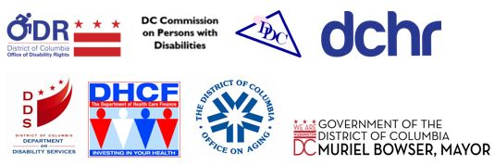
DC Office of Disability Rights, DC Commission on Persons with Disabilities, DC Developmental Disabilities Council, DC Department of Human Resources, DC Department on Disability Services, DC Department of Health Care Finance, DC Office on Aging

About the Expo
In recognition of October being National Disability Employment Awareness Month, the District of Columbia Office of Disability Rights (ODR), in partnership with several agencies, hosts the 11th Annual Mayor's Disability and Diversity Expo. The purpose of this free community event is to advance the conversation on equal opportunities and inclusive environments for people with disabilities, complete with break-out informational sessions and over 40 exhibitors. The District of Columbia is home to over 116,000 people with disabilities and more than 500 consumers, caregivers, advocates and students are invited to attend this year.
This years’ theme is America’s Workforce: Empowering All, and we are focusing on competitive, integrated employment. This year, ODR hosted our first on-site interviews with agencies currently hiring in the District. On October 18, 2018, we hosted a half day training session focused on resume development and interview skills training.
Through a partnership with United Healthcare, the DC Commission on Persons with Disabilities (DCCPD), the DC Developmental Disabilities Council (DDC), the DC Department on Human Resources (DCHR), the DC Department on Disability Services (DDS), the DC Department of Healthcare Finance (DCHF), and the DC Department on Aging (DCOA), the Mayor’s Disability and Diversity Expo will highlight the important initiatives and programs offered throughout the District.
Thank you to United Healthcare, District agencies, and community-based organizations for their support in conducting this year’s Expo. Furthermore, thank you to all District residents and advocates for attending the 11th Annual Mayor's Disability and Diversity Expo. Your partnership is greatly appreciated.
With great respect,
Director Mathew McCollough, The Office of Disability Rights
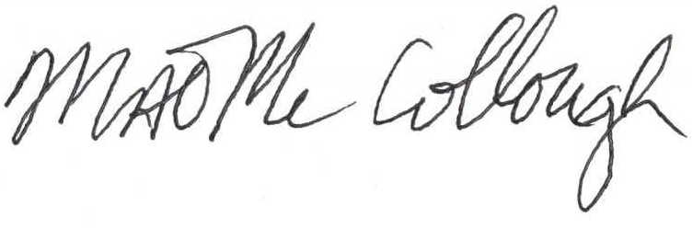

Agenda
Morning Session
10:00 AM
- Welcoming Remarks, Mathew McCollough, Director, Office of Disability Rights
- A word from our Sponsor, Ken Applewhite, United Healthcare
- Remarks by the 2018 Expo Ambassadors, Keith Wright, Kevin Wright, Anjie Shelby, and Grace Odrick
- Key-Note Speaker, Kevin Donahue, Deputy Mayor for Public Safety and Justice
- ADA Coordinator Graduation Ceremony
- Closing Remarks
Break Out Sessions
12:15 PM
Session 1. School to Work Transition
12:15 PM
Session 2. Know Your Employment Rights
1:20 PM
Session 3. Working Dogs in the Work Place
Onsite Interviews
1:30 PM to 3:00 PM

The 2018 Expo Ambassadors
The 2018 Expo Ambassadors are all DC residents who identify as a person with a disability and who have successfully accessed a program through the District Government. The Ambassadors can provide first-hand knowledge to others on the processes they went through to access these programs successfully.
- Keith Wright completed a six month internship with the DC Department of Human Services (DHS) where he was involved with design projects for the Office of Information Systems team. Mr. Wright designed sketches for the DHS website banner as well as posters and created a logo for the Knowledge Center on their website. To learn more about DHS and the services they offer, visit dhs.dc.gov.
- Kevin Wright completed a six month internship with the DC Department on Disability Services (DDS) where he worked on youth and transition services. During his internship Mr. Wright became a certified People Planning Together Trainer, which is a two day person centered thinking training focused on employment. To learn more about DDS and the services they offer, visit dds.dc.gov.
- Anjie Shelby has been a client of the Rehabilitation Services Administration (RSA) since 2012. RSA assisted Ms. Shelby in enrolling in and graduating from the University of the District of Columbia. She continues to work with RSA to find gainful employment. To learn more about the RSA and how to apply, visit dds.dc.gov/service/vocational-rehabilitation-services.
- Grace Odrick is a 2018 Arts and Humanities Fellow under the DC Commission on the Arts and Humanities (CAH) for her poetry. Ms. Odrick writes poems about her personal battle with mental health and shares them with audiences throughout the District. To learn more about CAH and their funding programs, visit dcarts.dc.gov/service/grants.

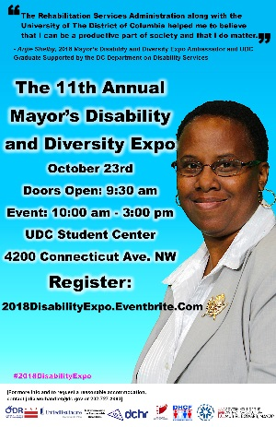
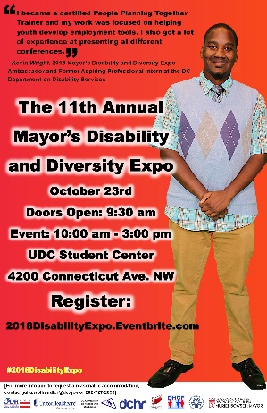
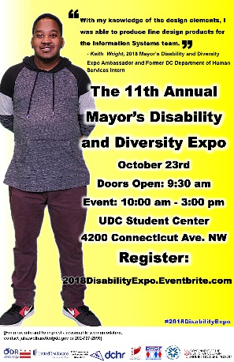
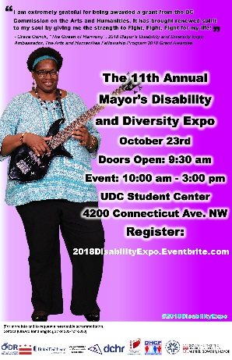
Anjie Shelby
Kevin Wright
Keith Wright
Grace Odrick

Exhibitors
  - Columbia Light House for the Blind
  - DC Commission on the Arts and Humanities
  - Consumer Action Networks
  - DC Board of Elections
  - DC Center for Independent Living
  - DC College Savings Plan
  - DC Office of Human Rights
  - DC Office on Aging
  - DC Public Library Center for Accessibility
  - DC Relay
  - DC Community Health and Wellness Center
  - Department of Transportation
  - Disability Community Outreach Collaborative
  - Disability Rights DC at University Legal Services
  - Easterseals Disability Staffing Network
  - Fire EMS
  - Full Circle Employment Solutions LLC
  - Go Grow & Be
  - HSEMA – Homeland Security Emergency Management Agency
  - Low Vision Specialists of Maryland and Virginia
  - MedStar Washington Hospital
  - Mid Atlantic ADA Center – TransCen, Inc.
  - Office of the Tenant Advocate
  - Prestige Health Care Resources
  - Project Action!
  - Quality Trust
  - RCM of Washington
  - Safe at Home Program (Home Care Partners)
  - Serve DC
  - Special Olympics, DC
  - The Department of Health Care Finance
  - The Department of Human Resources
  - The Department on Disability Services
  - The HSC Health Care System/ Health Services for Children with Special Needs
  - The Linner Foundation
  - The Salvation Army
  - United Healthcare
  - Washington Metropolitan Ear

Break Out Sessions

School to Work Transition
Speak with experts from School Talk, Department on Disability Services, and District youth leaders to learn about proactive initiatives to successfully transition from school to work.
Knowing Your Rights
Experts from the Office of Disability Rights and the Mid-Atlantic ADA Center will discuss the laws that individuals with disabilities are protected by and the process for requesting a reasonable accommodation during pre-employment, post-offer, and on the job.
Working Dogs in the Work Place
Join a guide dog user and a legal advisor to learn about the best practices for including service animals in the workplace and discuss the legal dos and don'ts. Audience members are invited to bring their service dogs and stories to share during the session.

Mission
To ensure that the programs, services, benefits, activities and facilities operated or funded by the District of Columbia are fully accessible to, and useable by people with disabilities. The Office of Disability Rights is committed to inclusion, community-based services, and self-determination for people with disabilities. ODR is responsible for overseeing the implementation of the City's obligations under the Americans with Disabilities Act (ADA), as well as other disability rights laws.

Contact Us
441 4th Street, NW, Suite 729N
Phone: 202-724-5055
Email: odr@dc.gov
Web: ODR.DC.GOV
Twitter: @ODRDC
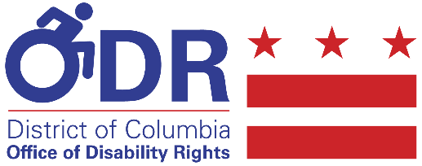
Facebook: @DisabilityRights

