Washington, DC
Muriel Bowser, Mayor

Proclamation

Americans with Disabilities Act DAY

July 26, 2020

WHEREAS, the Americans with Disabilities Act (ADA) was signed into law on July 26, 1990 to ensure the civil rights of citizens with disabilities; and

WHEREAS, today marks the 30th anniversary of the signing of the ADA, codifying critical efforts to expand access and opportunity for people with disabilities; and

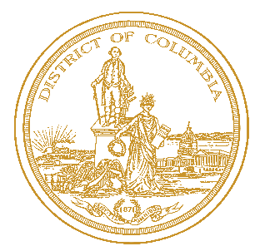
WHEREAS, Washington, DC, and our Office of Disability Rights, the DC Commission on Persons with Disabilities, the Department of Disability Services, and all other District government agencies are deeply committed to continued work to improve quality of life for all who have disabilities; and

WHEREAS, the District government is working steadfastly with all Washingtonians to ensure that the promise of hope and freedom envisioned by the passage of the ADA comes to fruition; and

WHEREAS, on behalf of all Washingtonians, I proudly recognize the many accomplishments made by our citizens with disabilities, as well as their tremendous contributions to exemplifying and bolstering our #DCValues; and

WHEREAS, Washington, DC is fully committed to achieving greater social, economic, and personal independence for individuals with disabilities:

NOW, THEREFORE, I, THE MAYOR OF WASHINGTON, DC, do hereby proclaim July 26, 2020 in Washington, DC as “AMERICANS WITH DISABILITIES ACT DAY” and encourage Washingtonians to join in celebration of the 30th Anniversary of its establishment.
