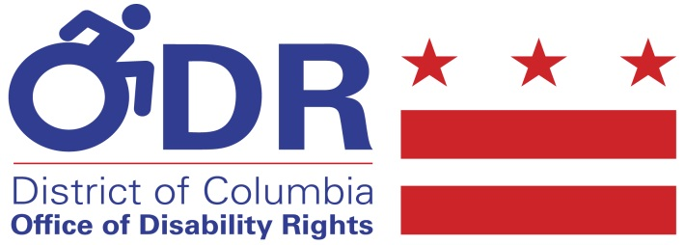

Organization | Contact Names | E-mail Addresses
Office of Disability Rights | Jessica Hunt, Mathew McCollough, Olmstead e-mail | Jessica.hunt@dc.gov  Mathew.mccollough@dc.gov  olmstead@dc.gov
Department of Aging and Community Living (DACL) | Heather Stowe, Adam Mingal, | heather.stowe@dc.gov  adam.mingal@dc.gov
Department of Healthcare Finance (DHCF) | Leyla Sarigol, Ieisha Gray, | Leyla.sarigol@dc.gov  ieisha.gray@dc.gov
Department on Disability Services (DDS) | Ed Bynum, Angela Spinella, Charlotte Roberts | Edward.Bynum2@dc.gov  angela.spinella@dc.gov  charlotte.roberts@dc.gov
Department of Behavioral Health | Raphaelle Richardson, Jonathan Brooks | raphaelle.richardson@dc.gov  jonathan.brooks@dc.gov
Department of Employment Services (DOES) | Michael Covin | Michael.covin@dc.gov;
Office of the People’s Counsel | Silvia Garrick | sgarrick@opc-dc.gov
Homeland Security Emergency Management Agency | Delores Scott | Delores.scott@dc.gov

