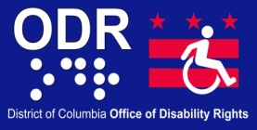
 ADA TODAY
Newsletter
Volume 4 Issue 1 November 2013

ODR Video Remote Interpreting (VRI) Service Center

The Office of Disability Rights (ODR) provides Video Remote Interpreting (VRI) service at its VRI Center, located at ODR’s location, Suite 729N, Judiciary Square. VRI is the use of a computer, webcam and a high speed Internet broadband connection to access a qualified American Sign Language (ASL) interpreter online. VRI is the use of a computer, webcam and a high speed Internet broadband connection to access a qualified American Sign Language (ASL) interpreter online.

VRI is perfect for last minute or emergency situations, such as walk-ins, interviews, or short meetings, in situations where an agency may need to conduct a short communication session between deaf and hearing individuals, but an in-person sign language interpreter (SLI) is not available.

Our VRI service is available during regular business hours for up to one (1) hour. VRI Services can be arranged in advance or requested on-demand by contacting ODR at 202-724-5055.
______________________________________________________________________________

Holiday Celebration for The Senior Citizens of DC

Presented by Mayor Vincent C. Gray
DC Office on Aging and the Senior Service Network
1:00 p.m. – 5:00 p.m. ~ DC Armory ~ 2001 East Capitol Street, SE
The Mayor's Annual Senior Holiday Celebration will be held under the theme “Live, Work and Play: An Age-Friendly Holiday Celebration,” captures the Mayor’s goal of ensuring that the District is known as an Age-Friendly City, an inclusive and an accessible environment that encourages active healthy aging. More than 3,500 residents expected to attend the largest event held for District senior citizens. Hosted by the DC Office on Aging, the event will feature live entertainment, musical guests, wellness demonstrations, free facials, manicures and massages, information exhibits featuring community and government resources, with a festive lunch. The event is free, but a ticket is required for entry. Call (202) 724-5626 to reserve your ticket today! Invite your friends to celebrate the season with you.
Cost: FREE, Tickets Required

The District of Columbia Releases Its First Alzheimer’s State Plan

Alzheimer's disease is the sixth leading cause of death in the U.S. and ranked as the ninth leading cause of death in the District
Washington, D.C. – Today, the D.C. Office on Aging (DCOA) announced the release of the District’s first-ever State Plan confronting Alzheimer’s disease.

November is National Alzheimer's Disease Awareness Month and according to the Alzheimer’s Association, 9 percent of seniors living in the District have the disease. This chronic illness not only impacts the lives of those with this disease, but has a profound effect on their families and social networks. For this reason, The District of Columbia State Plan on Alzheimer’s Disease seeks to set measurable goals to help improve the lives of District residents living with this disease and reduce the burden on caregivers and their families.

“We developed this plan to ensure that all residents diagnosed with Alzheimer’s disease and their caregivers receive the adequate support needed to reduce the burden that is often associated with this illness,” said BB Otero, Deputy Mayor for Health and Human Services.

The plan engages District government agencies, federal partners, the private sector, and non-profits to make Alzheimer’s disease a priority for the city. Additionally, the plan outlines several goals and inclusive strategies to enhance care and support for individuals suffering from Alzheimer’s.
These goals include:

- Developing comprehensive research and data,
- Enhancing quality care for seniors diagnosed with Alzheimer’s disease,
- Creating a robust public awareness campaign to increase awareness about Alzheimer’s disease throughout the District, and
- Improving training and workforce development.

“We understand that Alzheimer’s disease is a complex issue that will take time and collaboration for various stakeholders to address this problem. With an increase in the number of Washingtonians living with the disease, there will also be an increase in family caregiving demands, both emotionally and financially. Therefore, we have created a five-year plan that includes various short- and long-term solutions that seek to enhance the lives of persons with Alzheimer’s disease and their families,” said D.C. Office on Aging Executive Director Dr. John M. Thompson.

“The District of Columbia needs an ambitious plan to educate and support individuals with Alzheimer’s and those who care for them,” said Sally White, co-chair of the Senior Advisory Coalition and the executive director for IONA. “We look forward to working with the D.C. Office on Aging and others to meet the important goals set forth in the new State Plan.”
Click here to read The District of Columbia State Plan on Alzheimer’s disease.

Vander Cherry

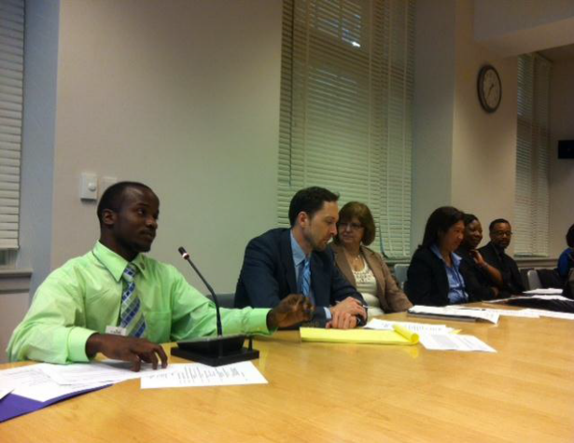

Vander Cherry (left), who received services from DCRSA through Vocational Rehabilitation Counselor Shonda Pertilla, has overcome the extraordinary challenges to employment success and has high hopes for the future – pictured here presenting to managers from the U.S. Department of the Interior and Office of Personnel Management.

Vander Cherry aspires to be a public speaker and advocate for people with disabilities. He gained momentum in the public speaking arena while participating in Project SEARCH, a school-to-career transition program at the U.S. Department of Education (DOE) during the 2010-2011 school year. DC’s Department on Disability Services introduced the Project SEARCH model into the Federal government in 2009 at the U.S. Department of Labor. Vander’s Project SEARCH site is co-sponsored by DC RSA and the DC Public Schools. Read More: http://dds.dc.gov/DC/DDS/DDS%20Publication%20Files/DDS_files/DDS%20Latest%20Headlines/DDS%20Succeeding%20Together-Vander.pdf
______________________________________________________________________________
COMMISSION ON HUMAN RIGHTS AWARDS
Honoring Our Past, Changing the Present, & Building Our Legacy for Tomorrow
Honoring Dr. Edgar Cahn
Thursday, December 5, 2013 - 5:00pm to 8:00pm
Kaiser Family Foundation’ Barbara Jordan Center
1330 G St NW Washington, DC 20005

If you are in need of an accommodation, please contact Stephanie Franklin at (202) 727-1145 by November 28, 2013.

The DC Commission on Human Rights is proud to present the Commission on Human Rights Awards Ceremony on December 5 at the Kaiser Family Foundation’s Barbara Jordan Center. During the annual celebration, the Commission will present its 2013 Cornelius R. “Neil” Alexander Humanitarian Award to Dr. Edgar S. Cahn, and announce the winners of the 2013 Youth Human Rights Ambassador Contest. The hors d’oeuvres reception begins at 5pm.

RSVP required by November 28. RSVP online at http://commissionawards.eventbrite.com or by calling (202) 727-0656.

About the 2013 Cornelius R. "Neil" Alexander Humanitarian Award:

This award is named in honor of the longtime Chief Administrative Law Judge of the Commission on Human Rights, who worked with the Commission for almost 20 years and was recognized as an expert in human rights. This award is presented each year by the Commission to a resident of the District of Columbia who has made a significant contribution in the field of human and civil rights and has helped to improve the quality of life in the District of Columbia.
____________________________________________________________________________

FEDERAL NEWS

Smithsonian to Spotlight Artists with Disabilities
A group of emerging artists with disabilities from across the country will take center stage at the Smithsonian Institution this fall.

The Washington, D.C. landmark will feature works of photography, painting and sculpture, among other mediums, from 15 artists with disabilities ages 16 to 25. Read More: http://www.nvrc.org/2013/09/smithsonian-to-spotlight-artists-with-disabilities/

______________________________________________________________________________

Jury Awards $240 Million for Long-Term Abuse of Workers with Intellectual Disabilities
Historic Verdict Against Henry's Turkey Service for Men Subjected to Verbal and Physical Harassment, Housed in Substandard Facilities, Denied Medical Care

WASHINGTON - A Davenport, Iowa jury today awarded the U.S. Equal Employment Opportunity Commission (EEOC) damages totaling $240 million - the largest verdict in the federal agency's history - for disability discrimination and severe abuse.

The jury agreed with the EEOC that Hill County Farms, doing business as Henry's Turkey Service subjected a group of 32 men with intellectual disabilities to severe abuse and discrimination for a period between 2007 and 2009, after 20 years of similar mistreatment.

"The verdict sends an important message that the conduct that occurred here is intolerable in this nation, and hopefully will help to restore dignity and acknowledge the humanity of the workers who were mistreated for so many years," said EEOC Chair Jacqueline A. Berrien.

The company is based in Goldthwaite, Texas, but the work and abuse occurred in West Liberty and Atalissa, Iowa. The jury awarded each of the men $2 million in punitive damages and $5.5 million in compensatory damages. This verdict follows a September 2012 order from the district court judge that Henry's Turkey pay the men $1.3 million for unlawful disability-based wage discrimination, thus making the total judgment $241.3 million. Read More: http://www.eeoc.gov/eeoc/newsroom/release/5-1-13b.cfm

HUD CHARGES NEW YORK HOUSING PROVIDER WITH DISCRIMINATING AGAINST RESIDENT
WITH DISABILITIES WHO NEEDED A SUPPORT ANIMAL
WASHINGTON - The U.S. Department of Housing and Urban Development (HUD)announced today that it is charging the East River Housing Corporation in New York, NY,with violating the Fair Housing Act by denying a request from a tenant with disabilities to reside in her apartment with a medically-prescribed support animal. HUD’s charge alleges that East River employees ignored the woman’s many requests to keep her emotional support dog in her apartment and moved to evict her when she refused to get rid of the dog.
The Fair Housing Act requires housing providers to make reasonable accommodations in their rules, policies, practices, or services when needed to provide persons with disabilities an equal opportunity to use or enjoy a dwelling. This includes waiving pet limitation policies for persons who need emotional support animals. Read More: http://portal.hud.gov/hudportal/HUD?src=/press/press_releases_media_advisories/2013/HUDNo.13-170

For Information about ODR’s Newsletter call 202-724-5055 or visit the web at odr.dc.gov.

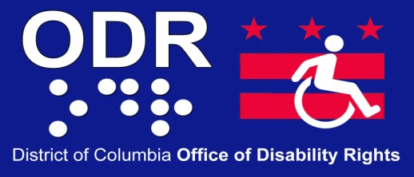

441 4th Street NW
Suite 729 North
Washington DC 20001

Phone: (202) 724 - 5055
Fax: (202) 727 -9484
E-mail:
ODR.Complaints@dc.gov

Visit us on the web: http://odr.dc.gov

MISSION STATEMENT
Visit us on the web: http://odr.dc.gov
The mission of the District Office of Disability Rights (ODR) is to ensure that the programs, services, benefits, activities and facilities operated or funded by the District of Columbia are fully accessible to, and useable by people with disabilities. ODR is committed to inclusion, community-based services, and self-determination for people with disabilities. ODR is responsible for overseeing the implementation of the City's obligations under the Americans with Disabilities Act (ADA) as well as other disability rights laws.

