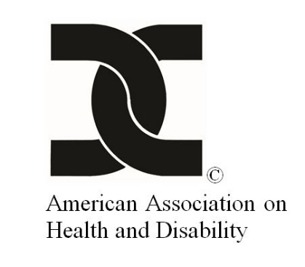

# **Call to Action to Promote the All of Us Research Program to People with Disabilities**

**Why Should You Participate In The *All Of Us* Research Program?**

“**Nothing About Us Without Us”:** This slogan is used to communicate the notion that no policy or practice, which affects the disability community, should be created without full and direct participation of members of the disability community. Historically, people with disabilities have been **excluded** and **ignored** from research studies. That ends **NOW** because of the *All of Us* Research Program!

Congratulations! The *All of Us* Research Program is **YOUR** chance to make an impact and get involved in direct, cutting-edge research to find solutions that could help people with disabilities. For the first time, people with disabilities are being encouraged to participate and are being asked to enroll in a study that can directly impact how health care is received in the future. If we truly believe in the concept of “nothing about us without us,” then **we must answer the call** when asked to participate.

**What is this Call to Action?** The American Association on Health and Disability (AAHD) is calling on **YOU** to learn more about and consider involvement in the National Institutes of Health’s (NIH) *All of Us* Research Program. If you are interested in participating in the research program, enroll at <https://www.JoinAllofUs.org/together>.

various individuals face the camera**What is the *All of Us*** Research Program?The NIH has created a nationwide research program focused on precision medicine, also known as personalized medicine, to help researchers understand more about why people get sick or stay healthy. The *All of Us* Research Program plans to **recruit one million** or more people to share their health and lifestyle data. The program recognizes the importance of recruiting traditionally underrepresented populations living in the United States (U.S.), providing the disability community a unique opportunity. When you join the program you will be contributing to an effort to improve the health of future generations while also advancing precision medicine and learning more about your own health, through better testing, better medicine and more information presented to you.

various profile shots of people. Text: Be One in a Million.The *All of Us* Research Program will provide researchers more information about people’s health and habits. By looking for patterns in biological, environmental and behavioral factors, researchers may learn more about what affects people’s health and, in turn, the best way to treat them. Currently, all eligible adults over the age of 18 who live in the U.S. can join the *All of Us* Research Program.

**What is precision medicine?** Health care has traditionally followed the same approach using a “one—size–fits—all” method, by prescribing treatment for diagnoses based on the average patient. Now, thanks to recent precision medicine initiatives, physicians are working toward tailoring treatment plans to the individual. For instance, many medical conditions, such as high blood pressure, are treated with a standard medication given to all patients and then trial and error is used to determine the best medication and/or dosage. Imagine a scenario where the individual’s treatment is already customized for the person based on factors known about them, including any disabilities. This research program **will advance precision medicine and focus on the individual.** Precision medicine ensures that lifestyle, environment and genetic factors are considered when physicians determine the course of treatment in order to provide the best possible care for each patient.

Man in a powerchair **What is the connection between *All of Us*, precision medicine and people with disabilities?** The program is looking at a diverse group of people with a variety of health statuses, who will aid in moving the health care profession toward a more comprehensive, individualized approach. As a community engagement partner with *All of Us*, AAHD is focusing outreach efforts on educating people with disabilities about the importance of participating in the *All of Us* Research Program. Researchers are emphasizing the importance of recruiting traditionally underrepresented populations living in the U.S., providing the disability community a unique opportunity to improve the health of people with disabilities. No one understands “underrepresented and underserved” like the disability community. Participation is especially important when you consider that people with disabilities have been previously left out of biomedical research either because researchers did not actively recruit them, or they were not prepared to provide the accommodations people with disabilities need to participate.

Woman in a power chair

**Why should people with disabilities participate in *All of Us*?** People with disabilities know all too well that health status isn’t just dependent on a medical diagnosis. The “one—size—fits—all” method is not effective, as each person is unique and requires individualized care and treatment. There are many physical and environmental barriers that are unique to the disability community, and the presence of secondary conditions and health disparities is often overlooked by health care providers. A visit to a health care provider can become an all-day event if a bus’s wheelchair lift is broken. A medication can be taken incorrectly if the instructions aren’t written in a format that a person can read, such as braille or large print. A serious medical condition can be misdiagnosed if a physician isn’t trained to understand all aspects of the primary and/or secondary condition. These issues can be detrimental to the health of people with disabilities. **This is your chance to change how medicine works. YOUR chance to solidify the slogan, “nothing about us without us.”**

**LogoFor more information** about how you can get involved in the *All of Us* Research Program, please visit the American Association on Health and Disability website <https://www.aahd.us/initiatives/all-of-us-research-program/> or visit the program’s website <https://www.JoinAllofUs.org/together>.