District of Columbia Commission on Persons with Disabilities
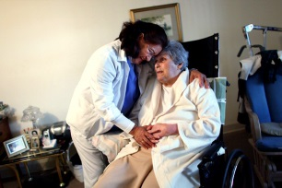
invites the community to attend the
Community Forum
Personal Care Attendants

Do you or someone you love use a Personal Care Attendant (PCA)?
Come out and hear about the new Personal Care Attendant initiatives, the rights of the consumer and how the District Government is here to help.
Save the Date
Saturday, March 8, 2014
1:00 PM – 3:00 PM
441 4th St, NW
Old Council Chambers
Washington, DC 20001
(Red line - Judiciary Square Metro Station)

For more information or to request reasonable accommodations please contact
Christina Mitchell at 202-481-3877 or christina.mitchell@dc.gov

