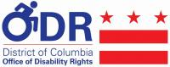
ADA TODAY
THE NEWSLETTER OF THE DISTRICT OF COLUMBIA
OFFICE OF DISABILITY RIGHTS

Volume 1, Issue 5, July 2017
Headlines from June

The Mayor’s Nomination
On July 3rd, Mayor Bowser announced the nomination of Mathew McCollough as the Director of the DC Office of Disability Rights. McCollough is currently the Executive Director of the DC Developmental Disabilities Council, Prior to serving the DDC McCollough served as the Communications Manager for the DC Office of Disability Rights, where he was the lead coordinator on issues related to Americans with Disabilities Act (ADA) compliance for DC Government. Between 2002 and 2008, he served as a Grants Manager and Trainer with the Association of University Centers on Disabilities and for the National Service Inclusion Project, a training and technical assistance provider that advocates on behalf of individuals with disabilities.
Figure 1. Headshot of Mat McCollough
Speak For The People
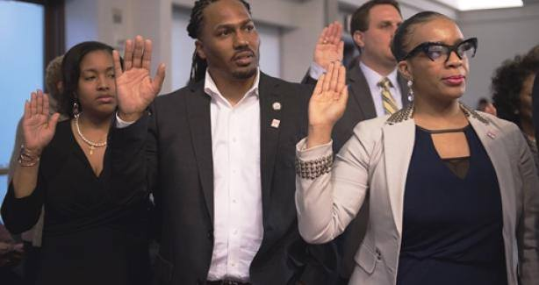
We would like to welcome our new commissioners to the DC Commission on Persons with Disabilities. To date the DCCPD has eight new commissioners who were sworn in this year. The Commission serves to advise the District on programs, services, facilities, and activities provided to residents, visitors and employees in the District of Columbia. The DCCPD meetings are open to the public. If you are interested in attending the next meeting, please contact Beatrice Schmidt, ODR’s Public Affairs Specialist. She can be reached by email at:Beatrice.Schmidt@dc.gov or by phone at (202)727-2890.
Figure 2. Commissioners at Sworn-in Ceremony
July Events

Is Your Website User Friendly?
SSB Bart Group will be holding FREE webinars on July 6th and July 20th to help you learn to create accessible websites. To learn more information go to ssbartgroup.com.

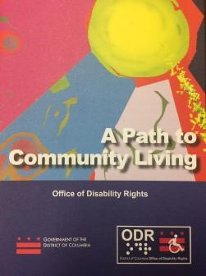
Olmstead Is In and Institutions Are Out
The Office of Disability Rights and the Department of Behavioral Health will be hosting its 9th Olmstead Community Integration Conference on July 14th. At this event, you can discover how people with disabilities are integrating into the community, securing services that can allow people with disabilities to live independently and speak to agency representatives about the Olmstead 2016 plan.

Figure 3. Book cover with title “A Path to Community Living”

NCIL Conference 2017
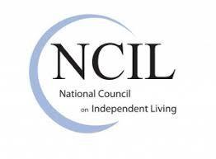
Are you a per Are you a with a person disability? Do you want to network or meet disability rights advocates? The NCIL Conference is the place to go to! The conference takes place in DC from July 24th to July 27th. To learn more, go to NCIL.org

Figure 4. Logo of the National Council for Independent Living

Let’s Celebrate the Americans with Disability Act
On July 27th join the American Association of People with Disabilities for their ADA Celebration to recognize the anniversary of the ADA. The 2017 ADA Celebration will bring together the national cross-disability community with business and government leadership. Buy your tickets here.

ODR Newsfeed

Four Ways to Make Your Next Meeting Accessible
Are you excited about making your next public event a huge success?
You can attract a larger crowd by making it accessible to people with disabilities.
1.Include a statement on your flier that explains what to do, if someone needs a reasonable accommodation to participate in your event.
2.Choose a location that is easy to get to by metro or bus.
3.Set up your meeting space in a manner that allows people with mobility devices to move around easily.
4.Provide information in alternative formats such as large print or braille.
Want to learn more? You can easily access our Guide to Accessible Meetings and Conferences.

Three Tips When Booking ASL Interpreters Through the Office of Disability Rights
The Effective Communication Program at ODR is designed so different DC offices can ask for an ASL interpreter if it is requested.
1. ODR’s website has an online form, and a printable form that can be used to make the request.
2. Provide meeting materials if possible at the time of your request including items such as PowerPoint presentations, fliers or the agendas.
3. Last minute bookings can be stressful. If you know of any future events that an interpreter will be needed for, let us know so we can make it happen.
If you have questions about our Effective Communication Program, please send an email to SLI.ODR@dc.gov .

For Information about ODR’s Newsletter call (202)724-5055 or visit the web at odr.dc.gov.

441 4th Street NW, Suite 729 North, Washington DC 20001, Phone: (202)724-5055
Fax: (202)727-9484 E-mail: ODR.Complaints@dc.gov

MISSION STATEMENT
The mission of the District Office of Disability Rights (ODR) is to ensure that the programs, services, benefits, activities and facilities operated or funded by the District of Columbia are fully accessible to, and useable by people with disabilities. ODR is committed to inclusion, community-based services, and self-determination for people with disabilities. ODR is responsible for overseeing the implementation of the City's obligations under the Americans with Disabilities Act (ADA) as well as other disability rights laws.

