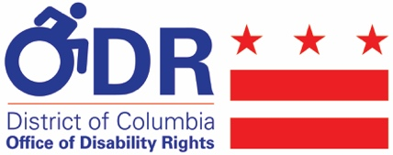
PRESS RELEASE

FOR IMMEDIATE RELEASE:
July 26, 2019

CONTACT:
Julia Wolhandler (ODR) - 202-727-2890; julia.wolhandler@dc.gov

Bowser Administration Recognizes the 29th Anniversary of the
Americans with Disabilities Act

(WASHINGTON, DC) - In recognition of the 29th anniversary of the Americans with Disabilities Act, Mayor Muriel Bowser has proclaimed July 26, 2019, as the Americans with Disabilities Act Day. The Office of Disability Rights (ODR) continues to train District of Columbia Government Staff and the community on the ADA to ensure the more than 91,387 District residents with disabilities are guaranteed rights and equal access under the law.

“Our citizens with disabilities strive for independence and respect, and they wish to do so with a sense of integrity and purpose,” said ODR Director Mathew McCollough. “The Office of Disability Rights and the District Government will always show our unwavering commitment to this community by furthering the compliance of the ADA and other federal and local disability-related laws impacting our residents.”
Signed into law by President George H.W. Bush on July 26, 1990, the ADA is the most comprehensive federal civil rights law that prohibits discrimination against individuals with disabilities in employment, State and local governments, public accommodations, commercial facilities, transportation, and telecommunications. The ADA ensures that individuals with disabilities have equal opportunities to that of their peers.

ODR will host an event this month in celebration of the 29th anniversary of the ADA. Residents are invited to join the agency to learn about the various resources available for emergency preparedness. For more information on this upcoming event, visit: odr.dc.gov/events.

###

Social Media:
ODR Twitter: @ODRDC
ODR Facebook: facebook.com/disabilityrights/
ODR YouTube: DC Office of Disability Rights
ODR Website: ODR.DC.GOV

